**Project Title:** Reddit Viral Posting AI Bot

**Brief Description:** Designed and implemented an AI-driven Reddit Bot that automates the creation and submission of posts to Reddit communities. This bot leverages OpenAI's ChatGPT to generate engaging content, ensuring high-quality posts that resonate with target audiences. The solution is designed to save time and effort, allowing users to focus on strategy while the bot handles the technical aspects of posting.

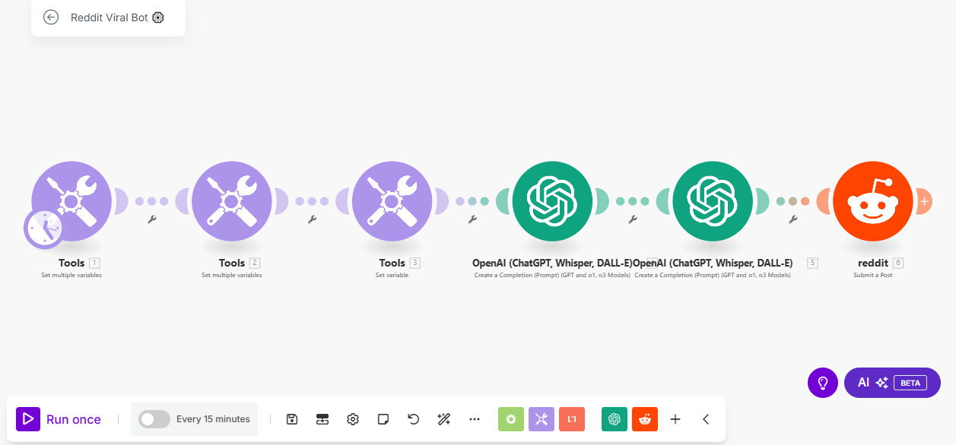

**Skills Used:** AI content generation, automation, social media management, and workflow optimization using Make.com. The bot integrates OpenAI's ChatGPT for intelligent content creation and Reddit's API for seamless post submission.

**Relevant Outcomes/Achievements:** Successfully developed a zero-coding, plug-and-play solution that runs on autopilot, making it accessible for users without technical expertise. The bot's ability to generate and post content every 15 minutes ensures consistent engagement with Reddit communities. This project has enabled users to increase their visibility and engagement on Reddit, leading to higher chances of achieving viral fame. The fully customizable nature of the bot allows users to tailor content to specific subreddits, enhancing relevance and impact.

**Key Features:**

* Automated post creation and submission using AI.
* Integration with OpenAI's ChatGPT for high-quality content generation.
* Fully customizable and adjustable to meet specific posting requirements.
* Zero coding required, ensuring ease of use for non-technical users.